1)

<https://looka.com/s/161995883>



Like = laptop imagery, cloud, person. Simple

Lacks = color ?

2)

<https://looka.com/s/162001014>



Like = neuron Y imagery implying connection

3)

<https://looka.com/s/161999697>

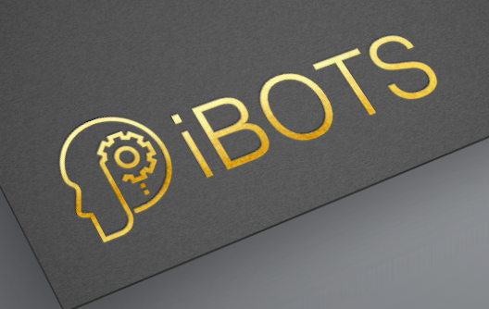

4)

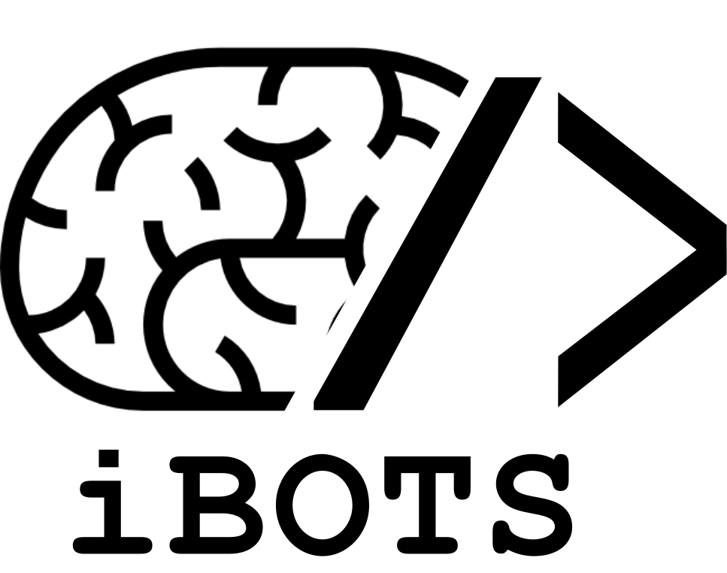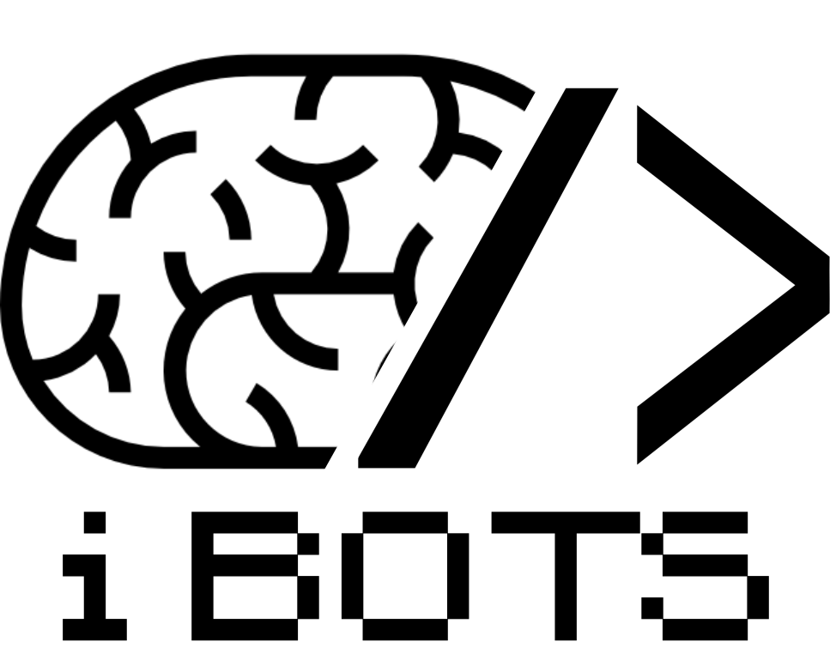

Like = coding represented, movement suggested with forwars slash

5)

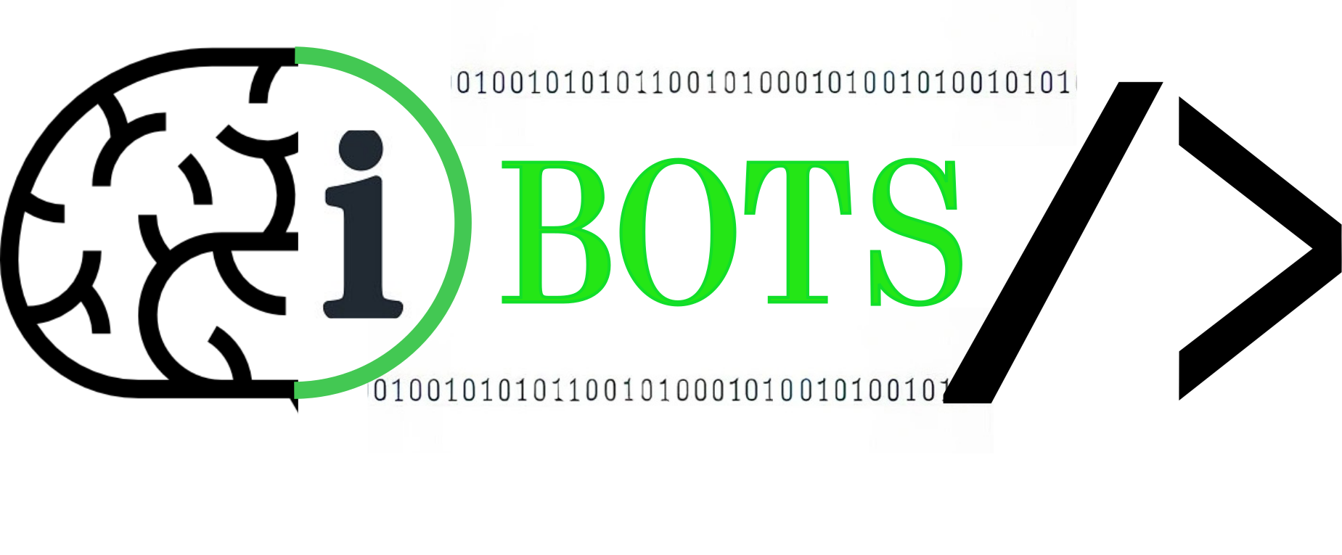

Like = links neuro with IT

Dislike = mouse not best representation of our work

6)



Like = element of connection

Dislike = connections all central

7)

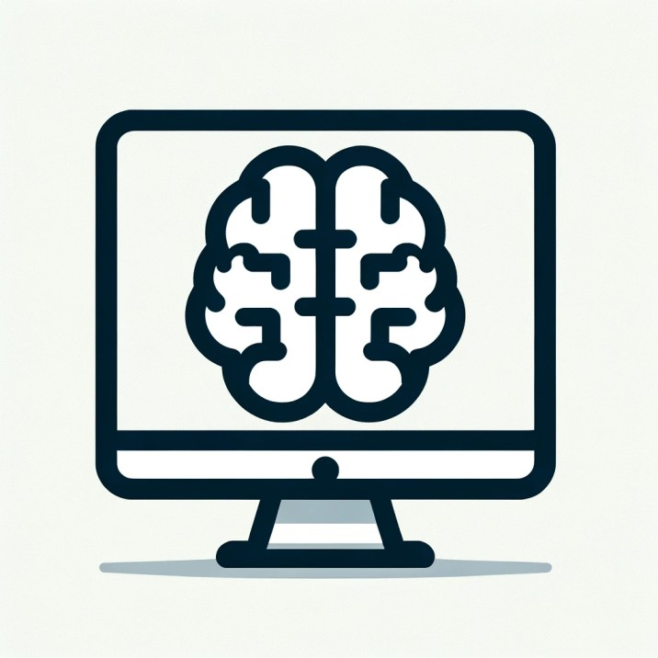

Like = colored i, movement aspect of brain, easily compactable

8)

